CSinParallel Project

August 13, 2014

- Contents: 2
  - Network Analysis with Hadoop 2
  - Advanced Network Analysis 3

Hadoop Network Analysis,

This module was created for CSInParallel by Jeffrey Lyman in 2014 (JLyman@macalester.edu)
The purpose of this module is to teach students how to analyze networks and datasets distributed over multiple files using the Hadoop framework. It is assumed that students are already familiar with the basics of hadoop and CSInPar- allel’s Web Map Reduce (WMR) hadoop interface.
The exercises in this module use a network of friendships on the social movie recommendation site Flixster. Students will use it to learn how to analyze networks and chain jobs.
The dataset can be downloaded from Academic Torrents

CHAPTER
ONE

CONTENTS:

Network Analysis with Hadoop

Network analysis is an important tool that has wide-ranging application from biology to marketing. This chapter will teach some basic techniques and show you how to chain together hadoop jobs using WMR to answer complicated questions.

    - The Dataset

The dataset we are using is a list of friendships on Flixster, a social movie recommendation website. The keys and values are numbers representing the two parties involved in a friendship. There is no significance to whether a friend is a key or a value.

System-dependent Alert
The path of the dataset shown below may not be the same on your WMR system. It is correct for this WMR server:
selkie.macalester.edu/wmr

The location of the dataset to use is called /shared/Flixster/edges.tsv. Enter this in the Cluster Path field on the WMR interface.

Getting a List of Friends

One of the basic network operations is retrieving a list of neighbors per node from a list of edges. In our case this means getting a list of friends from a list of friendships. The algorithm is quite simple, for each friend f in a friendship we must add f’s friend to the list of f’s friends.
Here’s our mapper:
1 def mapper(key, value):
2 #make sure our input is good
3 if not(key in (’’, None) or value in (’’, None)):
4 Wmr.emit(key, value)
5 Wmr.emit(value, key)

We want our reducer to output a comma separated list:

1 def reducer(key, values):
2 neighbors = set() #using a set ensures uniqueness
3 for value in values:
4 neighbors.add(value)
5 output = ’,’.join(neighbors)
6 Wmr.emit(key, output)

Average Friend Count

The output of the last job was interesting but doesn’t tell us much about the dataset as a whole. What if we wanted to know the average number of friends per Flixster account? This answer would be extremely difficult to answer in a single job. Luckily we can use the output of the last job as input for a new job. All you need to do is click the Use Output button at the top or bottom of the WMR results page.
To get the average, our mapper will output the number of friends each account has to one reducer that then calculates the average.
1 def mapper(key, value):
2 friends = value.split(’,’)
3 Wmr.emit(’Avg:’, len(friends))
4
5 def reducer(key, values):
6 count = 0
7 total = 0
8 for value in values:
9 count += 1
10 total += int(value)
11 Wmr.emit(key, total / count)

Note: It’s always a good idea to save the code you write for hadoop jobs as it is easily reusable.

Submit the job. If you did everything correctly, you should get Avg: 7.289679 as the output. That’s it, you now know how to chain Hadoop jobs. In the next chapter we’ll cover some more advanced network analysis operations.

  - Advanced Network Analysis

For this next exercise we will try to find the clustering coefficient for each node. The clustering coefficient is a number from 0-1 that represents how closely connected a node’s neighbors are is. It is calculated by counting all of the edges that a node’s neighbors share with each other and then dividing that number by the largest number of edges that they could share So if all of an account’s friends are friends with each other, that account’s clustering coefficient is 1 and if none of the account’s friends are friends with each other, the account’s clustering coefficient is 0.

A Mathematical interlude

In order to develop a map reduce algorithm to calculate the clustering coefficient, we need to understand the mathe- matics. The number of edges in a complete (fully connected) graph of N nodes is (N × (N − 1))/2.
This is because each of the N nodes has an edge between it and the other N-1 nodes. We divide by two because otherwise we would be counting each edge twice, once for each node that forms the edge.
We can find the number of edges a node’s neighbors share by examining the list of points that can be reached by two hops. the node’s neighbors will appear in this list once for each edge they share with another neighbor. Therefore the

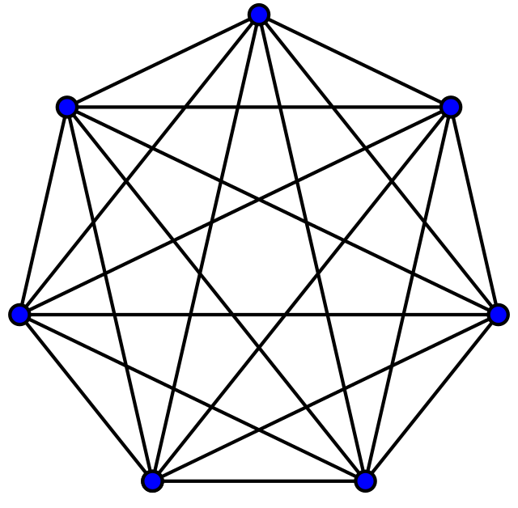

Figure 1.1: Image from Wikipedia A complete graph on 7 nodes has (7 * (7 -1))/2 = 21 edges

number of edges a node’s neighbors share is the number of times it’s neighbors appear in the two hop list divided by two. Again the division is necessary because both of an edge’s end points appear in the two hop list.

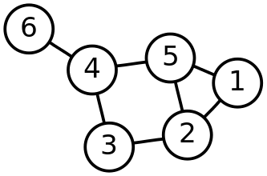

Figure 1.2: Image from Wikipedia

In the above graph, 5’s neighbors are 1, 2 and 4 3’s two hop list is 2,5,1,3,5,3,5,6
1 and 2 each appear once so 5’s neighbors share one edge 5’s clustering coefficient is 1 / ((3 * (3-1))/2) = 1/3

Writing the Algorithm

The Mapper

First we will need to have a list of the friends and friends of friends for every account. We can do this by sending each account’s list of friends to each of it’s friends. We also need to pass the account itself to the reducer so that it will be able to build a list of it’s friends. Here’s the code
1 def mapper(key, value):
2 friends = value.split(’,’)
3 for friend in friends:
4 Wmr.emit(friend, (key, value))

But what do we use as input? We already created friend lists for each account in the last chapter. We could use this as input for our clustering coefficient job. However this will cause a few problems because WMR crashes when the values the mappers emit are too large and some accounts have thousands of friends. It’s also not a good idea to have a single mapper emitting a thousand values. We can get around these limitations by breaking the friend lists into chunks before we run the clustering coefficient job.
Our new friend list job uses the same mapper as the one in the last chapter, but a modified reducer that outputs 50 friends at a time.
1 def reducer(key, values):
2 neighbors = set()
3 for value in values:

4 if len(neighbors) > 50:
5 Wmr.emit(key, ’,’.join(neighbors))
6 neighbors = set()
7 neighbors.add(value)
8 if len(neighbors) > 0:
9 Wmr.emit(key, ’,’.join(neighbors))

The Reducer

Our reducer takes the lists of friends of friends and makes a collection of it’s one and two hop neighbors. We use a set for the collection of one hop neighbors because we will receive the same friend multiple times if it has a large friend list.
We will use a dict to store the number of times a node appears in the two hop collection because it saves us a bit of memory and allows us to avoid counting instances of an element in a list which would be expensive.
1 def reducer(key, values):
2 oneHops = set() #friends
3 twoHops = {} #friends of friends
4 for value in values:
5 node, hops = eval(value) #unpack the values
6 oneHops.add(node) #reconstruct the friend list
7 hops = hops.split(’,’)
8 for hop in hops: #build the two hop dict
9 if hop in twoHops:
10 twoHops[hop] += 1
11 else:
12 twoHops[hop] = 1
13 n = len(oneHops)
14 if n < 2: #if a point has less than 2
15 Wmr.emit(key, 0) #neighbors it’s cc is 0
16 else:

17 | total = 0.0
18 | for hop in oneHops:
19 | if hop in twoHops:
20 | total += twoHops[hop]
21  22 | cc = total / (n * (n-1)) Wmr.emit(key, cc) | #calculate the cc

Challenge exercises for you to try

      - Calculate the average value of the clustering coefficient. Can you reuse the code from the last exercise?
      - Develop a chain of jobs to count the number of triangles
in the network. (Hint: pick a point to be the tip of the triangle)
      - Using code from the previous challenge, come up with
another way of calculating the clustering coefficient. You can test your algorithm by comparing the average with the average you calculated in the first challenge.

